DIPLOM

Trivsel 24/7 Marathon – 15.10.2017

Støtte løb: Støt brysterne. Samlet overskud.
3700 KR.
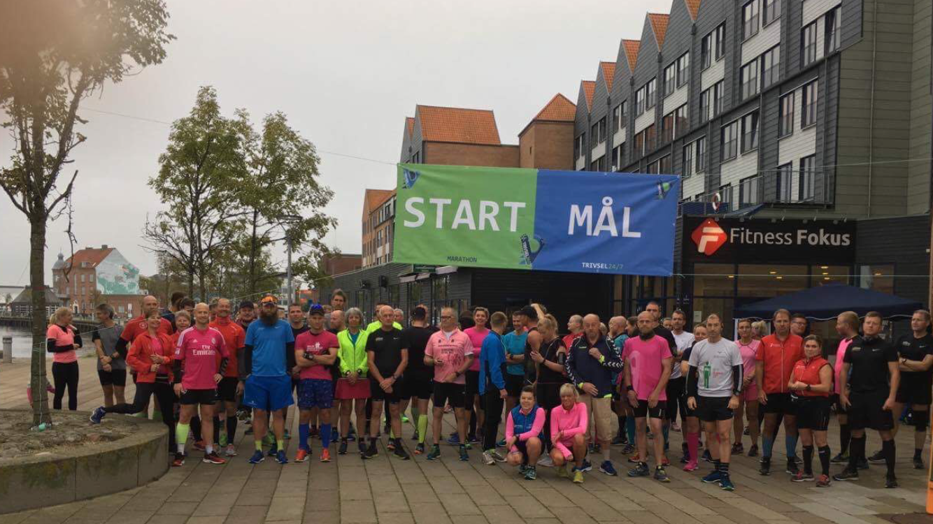

Distance: 7 km, 14 km, 21,1 km & 42,195 km.

Navn___________________________

Tid_____________________________

Deltagere på 7 km:

Christina W Clausen 44:37
Conni Mikkelsen 1:17:00
Sidsel Kirkegaard 39:45
Maria Færge Bols 45:00
Sten Larsen 39:47
Michael Tribler 37:55
Nicolaj Jørgensen 34:16
Anders Feldberg 44:13
Peter Jensen 42:10
Jacob Schwartzbach 44:14
Ditte Rottbøl 50:13

Deltagere på 14 km:
Poul-Erik Christensen 2:02:00
Maja P Madsen (Mangler tid)
Susanne Jørgensen 1:38:11
Louise Bødker 1:22:50
Rene Simonsen 1:19:46
Laura Vedel Hansen 1:09:49
Finn Vedel Pedersen 1:09:50
Lasse Freisleben 1:05:00
Camilla Rasmussen 1:19:46
Charlotte Freisleben 1:18:38
Jimmi Larsen 1:08:28
Nanna Madsen 1:43:28
Allan Rosenberg 1:10:00
Kitt Krogh 1:37:08

Deltagere på 21,1 km:
Camilla Skree 2:44:05 (DEBUT)
Winnie Thorsø 2:21:38
Jonas Seiling 2:12:10
Lars Jakobsen 1:59:35
Jeanette Wly 2:22:07
Heidi Nielsen 2:18:00
Finn Danielsen 1:59:44
Brian Jørgensen 1:34:22
Marianne Kryger 2:28:37
Jacob W Clausen 1:50:11
Line Feldberg 2:01:53
Henrik Larsen 2:02:48
Torben Witzell 2:25:03
Lea Witzell 2:25:03
Jesper Jensen 2:02:34
Erik Ralsted 1:57:40
Ebbe Larsen 2:22:05
Søren Lerche 1:59:28
Jørgen Hansen 2:25:10
Kenneth Provstgård 2:14:25
Winnie Kærgaard 2:22:05
Dorthe Ullegård 2:08:37
Jesper Diamant 1:44:08
Carsten Peterson 2:04:17
Laila Hallengreen 2:14:55
Jens Hallengreen 2:07:02
Lars Møller 2:06:31
Birthe Sønderskov 2:21:02
Lotte Sivertsen 1:58:32
Jarl Thrane 2:01:00
Jesper Nygård 1:44:36
Stig Andersen 2:04:14
Susan Hilden 2:04:17
Gitte Müller 2:15:00

Deltagere på 42,2 km
Line Kallehauge 5:05:36
Lars Madsen 3:53:58 (DEBUT)
Louise Blok 5:24:17
Harry Cilleborg 5:24:17
Brian Vernersen 4:19:29
David Bredo 4:14:04
Pia Hansson 5:05:36
Klaus Udsen 4:39:36
Mads Mikkelsen 4:45:40
Jan Kastrup 5:24:17
Ove Pedersen 5:05:36
Bouchra Lundgren 3:26:02
Johan Melin 3:56:05
Carsten Friis 4:19:37
Ulrik Pihl 3:56:05
Morten Blok 4:39:36

